Hi [Customer Name],

Thanks for sending us your product. While Asurion strives to ensure the best customer service, we couldn’t complete your repair for the following reason:

• [REASON]

We are returning your product in “as is” condition. If you have any questions, please call 1-.913-717-7779

We apologize for any inconvenience.

Asurion

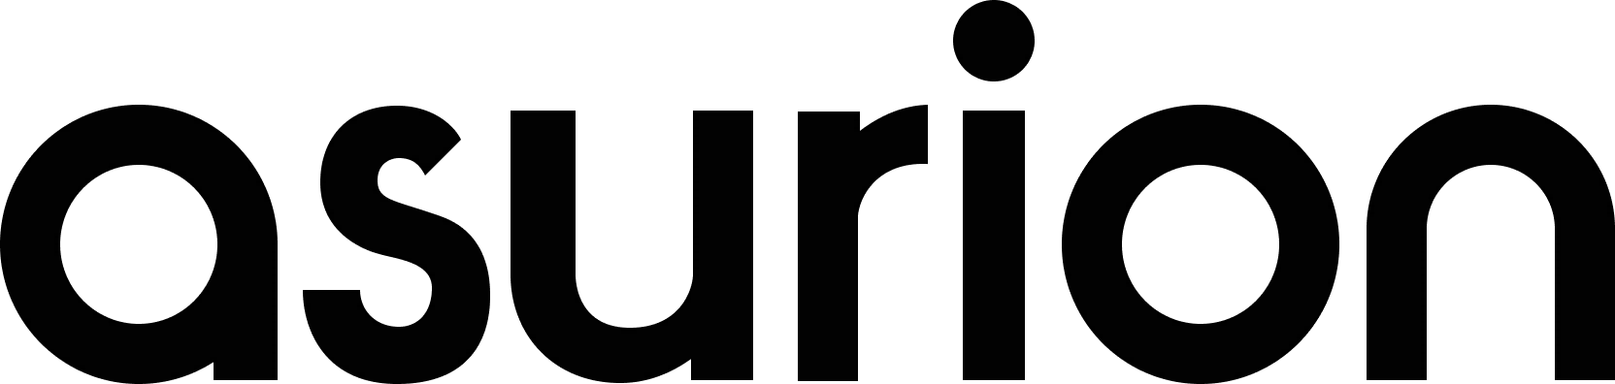Your Protection Plan Administrator

|  |  |  |
| --- | --- | --- |
| CLAIM INFORMATION | | |
| Service Request (SR#): [SRNUMBER] | Date Received: [DATERECEIVED] | Date Shipped: [DATESHIPPED] |
| PRODUCT INFORMATION | | |
| Product: [PRODUCT] | Model: [MODEL] | |
| Manufacturer: [MAKE] | Serial #: [SERIAL] | |
| BOX CONTENTS | | |
|  | | |
| Please note that cosmetic damages such as scratches or dents that do not impede the functionality of the product are not covered per the terms of your Protection Plan. | | |

©2017 Asurion, LLC. All Rights Reserved

ASCORP-4706-17 MKT59088

F-003-900 Not Authorized to Repair Form

Revision #: 6